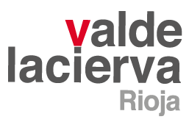

VALDELACIERVA CANTOGORDO 2018 – UNIQUE VINEYARD
GRAPE VARIETY: Tempranillo.
VINEYARD: Cantogordo (Samaniego). Bush vines planted in 1961 at an altitude of 530 metres above sea level. The vines are planted on a south-west to north-east axis on a 5% slope.
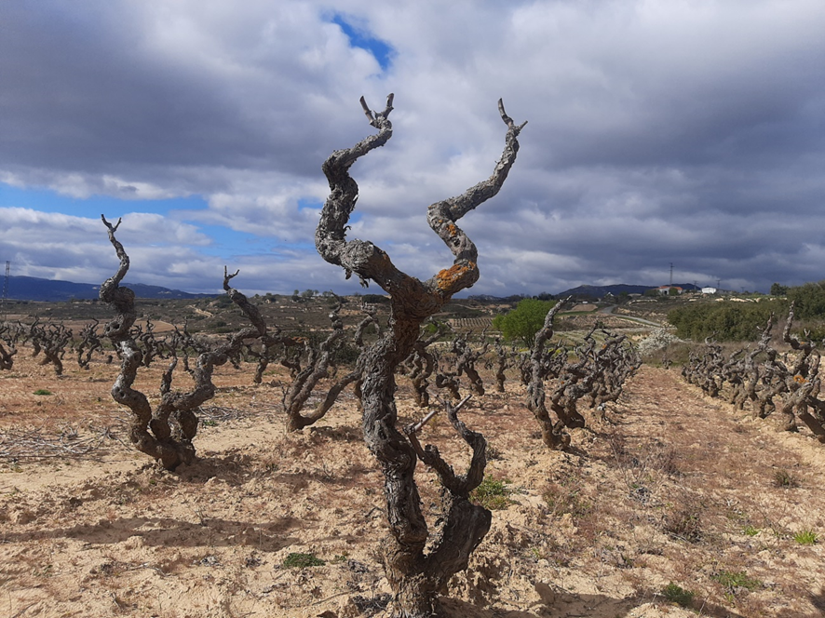
GEOLOGY AND SOIL: Predominantly sandy with patches of limestone from the bedrock which is about 90cm below the surface.
HARVEST: Manual harvest in boxes, with the grapes kept and transported to the winery chilled at 6°C. The 2018 vintage had a marked Atlantic influence which gives the wine an interesting natural acidity which makes it fresh and direct on the palate. The large temperature difference between day and night while the grapes were ripening guaranteed a high degree of synthesis between the phenolic compounds and aromatic precursors. Harvest took place during the second week in October.
VINIFICATION: The Tempranillo grapes from the Cantogordo vineyard are kept chilled at 6°C for 24 hours before going into a 700 litre, open-topped vat for a three day, pre-fermentation cold maceration. After three days, alcoholic fermentation begins at a controlled temperature of between 23ºC and 26ºC, with manual punching down of the cap. After racking, the wine undergoes malolactic fermentation in 500 litre French oak casks. It is then aged in the same casks for a further 15 months. The wine spends a final 15 months in bottle before leaving the winery.
TASTING NOTES: Intense, brilliant ruby. A complex and very intense nose, with dominant floral aromas and blue berries. A swirl of the glass releases more balsamic notes of thyme, fennel and other wild mountain herbs. The wood is well integrated in the wine, and complements primary and secondary aromas with toasted and black pepper notes. Very long on the palate with granular tannins and a nice tension from the limestone base. Strong and straight attack over the palate thanks to the good acidity and crunchy tannins. The wine has a long finish.
SERVING TEMPERATURE: 15 - 17ºC.
NUMBER OF BOTTLES:
